Get Connected

HOW DO I MEET AND CONNECT WITH OTHERS?
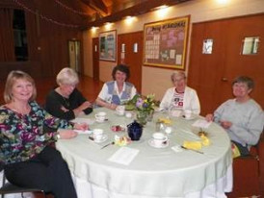 | Get to know each other...  Share a cup of coffee and light snack after worship services, where friendships can begin.

Grow together...  Participate in one of several Bible studies that meet during the week. Our small group bible studies include fellowship, so you can easily get to know others.  - Men's Bible Study  - Serendipity Women's Bible Study  - Sisters in Prayer (SIP) Bible Study  - Presbyterian Women's Assn. Bible Study | 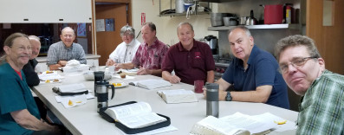

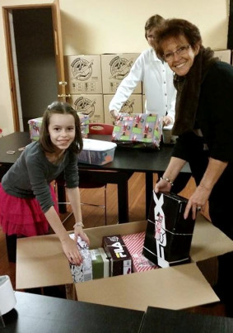 | Serve side by side...  Get involved in one of several ministries. If you desire to serve, we have a place for you! Volunteering in an area of ministry that interests you will put you in touch with like-minded people.  - Deacons  - Mission Trip  - Buildings and Grounds  - Prayer Shawl Ministry  - Pray for our Church Family  - Sanctuary Guild  - Operation Christmas Child

