Who to Expect

Who is First Presbyterian Church of Ukiah?

Our Purpose Statement: "Our purpose as an intergenerational church is to share the love and truth of Jesus Christ with each other, our community, and the world."
Newcomers
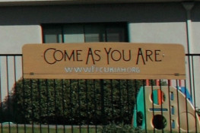
First Presbyterian Church of Ukiah (FPCU) is a "come-as-you-are" church with a casual atmosphere and a message that is relevant for everyday life. Perhaps you are new to our church, or even new to worship services in general. Perhaps you haven't attended for a while. In any case, in a new church, most of us find ourselves, at some time or another, wondering "What do I do next", or "Where do I fit in?" Hopefully this will help you to relax and feel comfortable. We also hope you will find a meaningful worship experience here. We look forward to meeting you!

WORSHIP SERVICE
What is Worship? Worship is the core of our identity as a faith community. Worship is what we say and do in our lives that tells about God's greatness and gives thanks to God for everything God has done for us in Jesus Christ. Worship is not only something that we do on Sunday mornings; it's something that we do with our whole lives. | 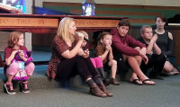

What should I expect at Sunday worship? We offer worship services every Sunday morning at 10:00 am. Our worship style is '"blended", meaning we offer a balance of traditional hymns and liturgy, as well as more contemporary songs that offer a more open style of worship. This blend provides a sense of community and a chance for people of all ages to participate in the service. A short Children's Sermon is included.

Do I have to look and act a certain way? Who is welcome? We invite you to come as you are! Our congregation has worshipers with dressy attire and also those who wear casual clothes. But the real point is exploring a relationship with God in connection with a faith community. Anyone honestly seeking to grow in their understanding of Jesus Christ will find a welcome place in our congregation.

Communion
We serve communion the first Sunday of every month, every Sunday during Lent, and for other special services. We believe the Lord's Table is available to all believers, not just Presbyterians. All are invited to encircle the Sanctuary as a family as we are served a piece of torn bread, which is then dipped into a common bowl. If you need to be served from the pew, the pastor or server will come to you. Remember: all believers are welcome to share in fellowship around the Lord's Table.

Children
Children are welcome to participate in our worship services. After a time of praise worship, children in Pre-school through 6th grade are dismissed to Sunday School (September thru May). Nursery care is provided for children age 3 and younger.

Friendship Hour
Immediately following worship, we invite everyone to the fellowship hall for coffee, beverages and light snack. This provides an opportunity to meet new people, get to know others a little better, and a chance to learn more about our church and its offerings. All are welcome to join us.

PARKING
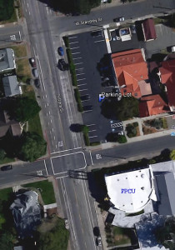 | We have a parking lot across Perkins Street (immediately north of the church) as well as plenty of street parking. In front of the church is a handicapped parking space as well as a passenger loading zone. We have no stairs at the main entrance, so our facility is easily accessible via wheelchair.

